Lab#07
Construct if else statements in java
Objective
Implementation of various decisions making constructs.
Lab Goals
To provide working insight into the usage of decision making statements using the following:
a. If statement.
b. If then else statement.
c. Nested If statement.
Introduction to Decision making statements
Decision making statements contain conditions that are evaluated by the program. If the condition is true, then a set of statements are executed and if the condition is false then another set of statements is executed. ... Otherwise, statements in the body of else are executed.
If statement
If statement is the simplest decision making statement. It is used to decide whether a certain
statement or block of statements will be executed or no
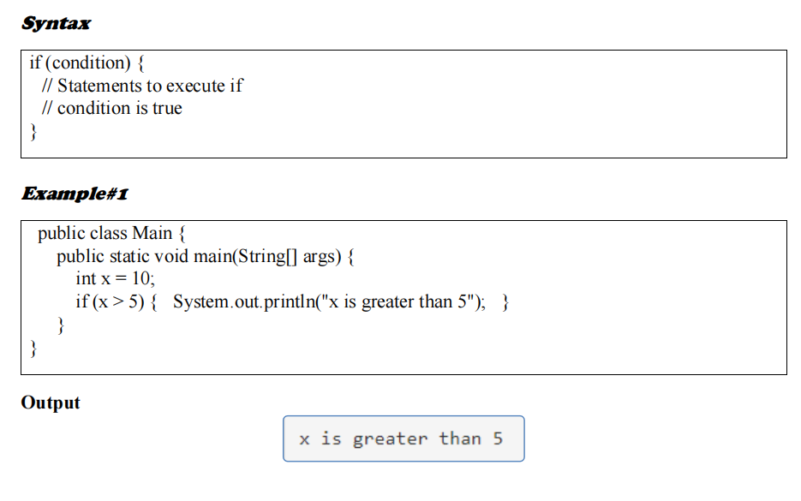

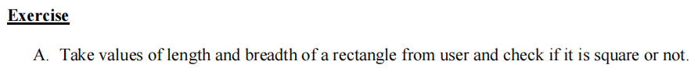
Program:
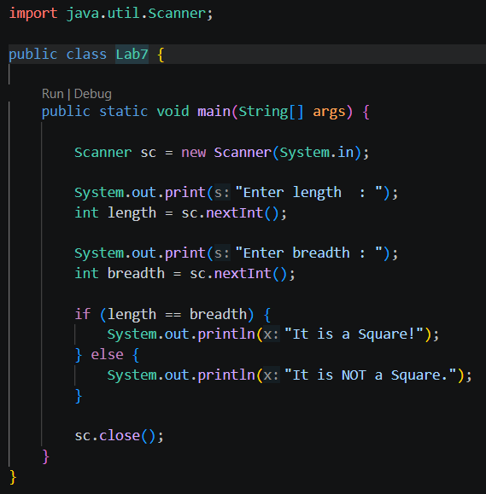
Output:
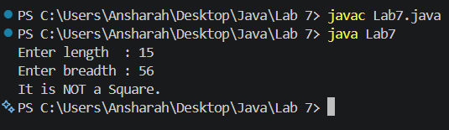

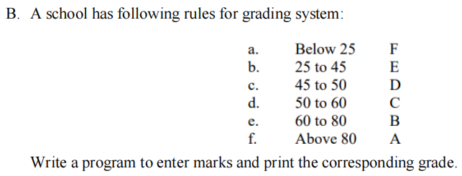

Program:
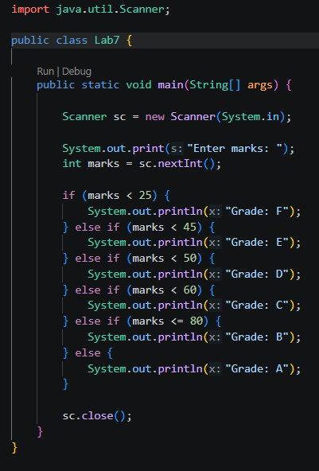
Output:
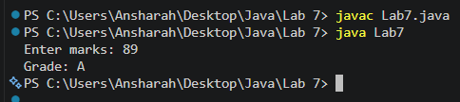
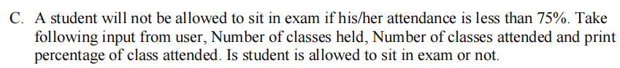
Program:
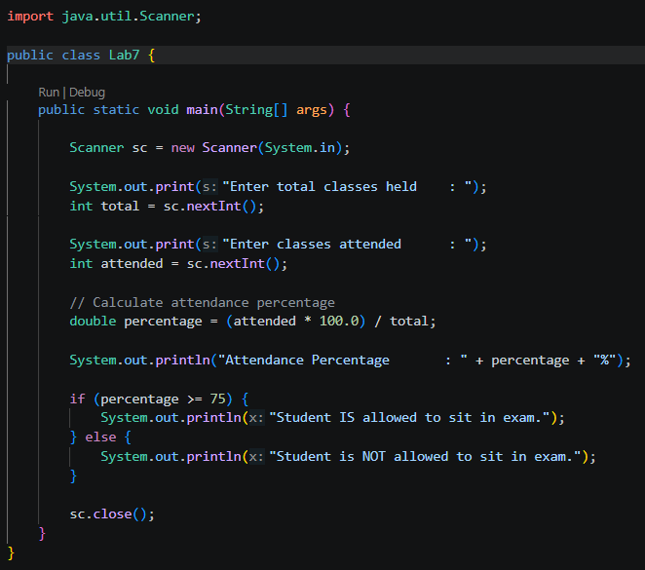
Output:
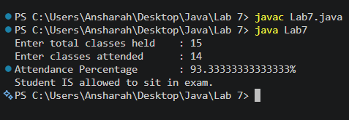
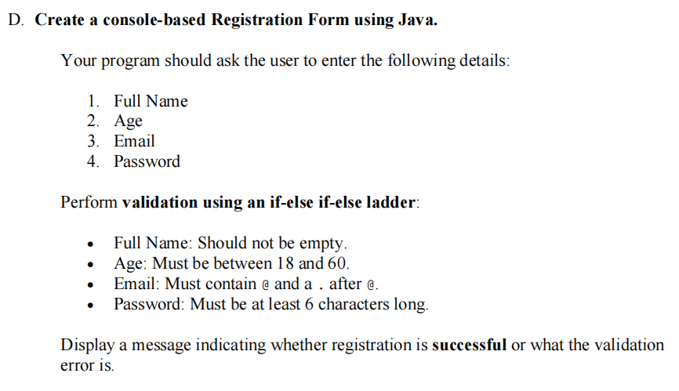
Program:
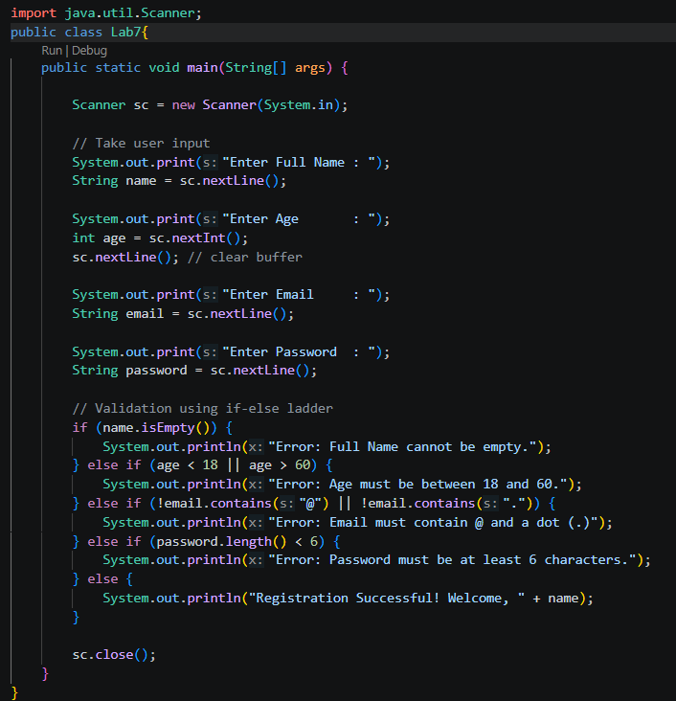

Output:
